In this lab we studied open collector logical circuits. They are used for designing logical circuits and bus design. The diference between TTL and open collector is the number of transistors.

We can see how a nand gate works using open collector logical circuits. We can choose to have a faster nand gate by using a smaller resistance, but the power consumption is bigger or we can have a slower but a more current efficient nand gate using a bigger resistance.

DC Analysis :

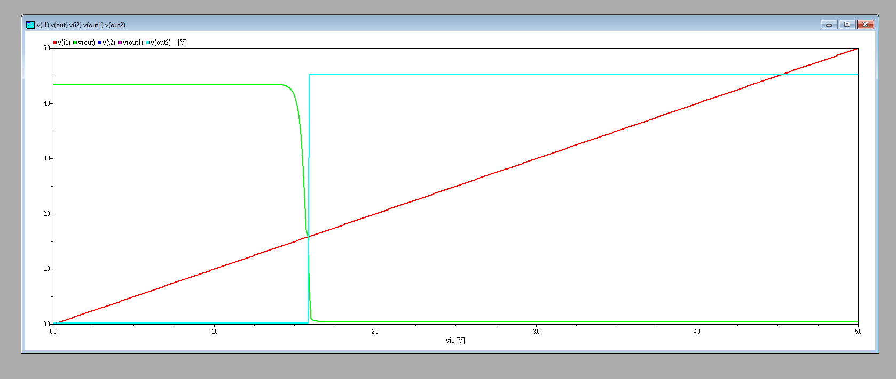

TR-ANALYSIS 0.5K RESISTANCE :

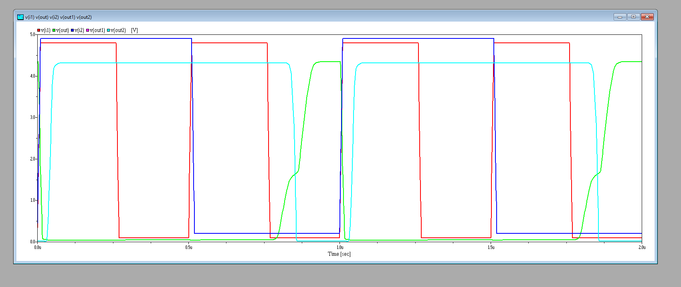

TR-ANALYSIS 2K RESITANCE :

